**Crowd Funding Analysis**

**Overall analysis**

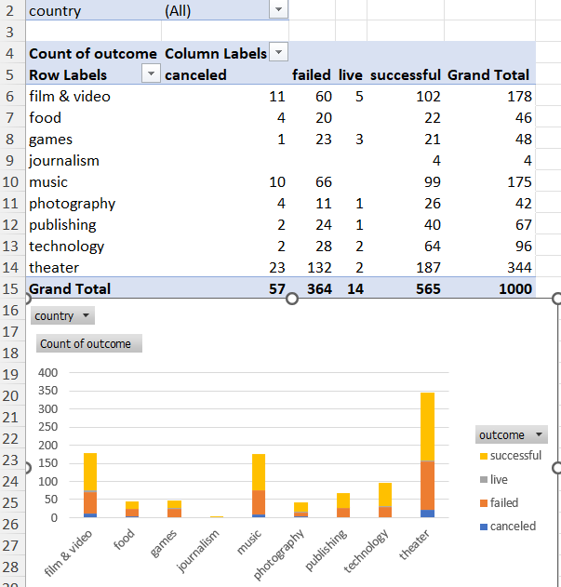

Overall, the funding the percent of successful funding is higher than failed. By looking at above Parent Category and the outcome, the entertainment categories like film & video, music, and theater are popular categories with the crowd funding with more than 50% success rate. Technology also has high success rate. The games category has higher failed rate than success.

There are a couple of limitations with this data set. The amount of campaigns for each category is not evenly distributed and the parent category is also limited withing a few industries. The data covers 2010 to 2020 and some of the category from older years may not reflect the popularity of popularity for current year.

It would be nice to see the goal analysis based on the category, percent funded and number of backers to compare which category has more likely to get funded by checking at percent funded and also see if they would correlate the backers-count. It would be nice to see County under row levels to easily compare which country has better success rate or it does even matter.

**Statistical analysis**

|  |  |
| --- | --- |
| **Statistical Analysis on Successful Outcome** | |
| Mean | 851 |
| Median | 201 |
| Minimum | 16 |
| Maximum | 7295 |
| Variance | 1606216.594 |
| Standard Deviation | 1267.366 |

|  |  |
| --- | --- |
| **Statistical Analysis on Failed Outcome** | |
| Mean | 586 |
| Median | 115 |
| Minimum | 0 |
| Maximum | 6080 |
| Variance | 924113.455 |
| Standard Deviation | 961.308 |

By looking at the mean and median of both successful and failed campaigns, using median would better summarize the data since there is a huge difference between these two numbers.

The data seems to be skewed with outliers.

The standard deviation and variance of successful and failed campaigns indicates that the successful has more variability than failed since the amount is larger. It makes since the data set of successful campaigns is more than that of failed ones.